**April/May 2017 News for**

**The Bouncy Bugs and Golden Guppies**

**This Month**

Color- Purple

Topics- Spring flowers,

Caterpillars and Butterflies, All About Me

**Important Dates**

Thurs., 4/6 – CF March

Thurs., 4/13 – Glee Open/Spring Hat Parade!

Thurs., 4/20 – Purple Day!

Thurs., 4/27- Bring favorite stuffed animal to school.

Thurs., 5/4- Beach Towel Day

Thurs., 5/11- Teddy Bear Picnic

**Tuesday, 5/16- Glee Closed,**

**Election Day**

**Wed., 5/17 – Bouncy Bugs Class 12:00-2:15**

Thurs., 5/18- GLEE end of the year show for the BOUNCY BUGS AND GOLDEN GUPPIES– 9:00 AM!

Last Book Order will be due on **Thursday April 20th.** Thank you to all who have ordered books this year, We have been able to order wonderful books and supplies for our classroom with points earned from your orders.**☺**

C:\Users\cjhansen912\AppData\Local\Microsoft\Windows\Temporary Internet Files\Content.IE5\0FBRJKT8\MC900410609[1].wmf

**April Fingerplays**

**The Rainbow**

(to the tune of Twinkle Twinkle Little Star)

Red and orange,

Green and blue,

Shiny yellow,

Purple too.

All the colors that I know

live up in the rainbow.

Red and orange,

Green and blue,

Shiny yellow,

Purple too!

**Rain**

Rain, rain go away!

Come again another day!

(Children’s names) want to play!  
Rain, rain go away!

**Home for me!**

Here is a nest for the robin.

Here is the hive for the bee.

Here is a hole for the bunny.

Here is a home for me!

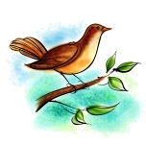

**Leaves, Branches, Trunk and Roots** (to the tune of Head, Shoulders, Knees and Toes)

Leaves, Branches, Trunk and Roots. Trunk and Roots (repeat)

Watch us change the whole year through.

Leaves, Branches, Trunk and Roots. Trunk and Roots (repeat)

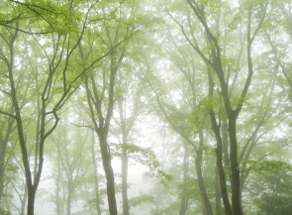

**Fun in the Rain**

When the rain comes down,

Drip, drop, drip, drop,

Windshield wipers go

Flip, flop, flip, flop.

And boots in puddles go

Plip, plop, plip, plop.

I wish the rain would never stop.

Drip, drop, drip, drop.

Flip, flop, flip, flop.

Plip, plop, plip, plop. SPLASH!